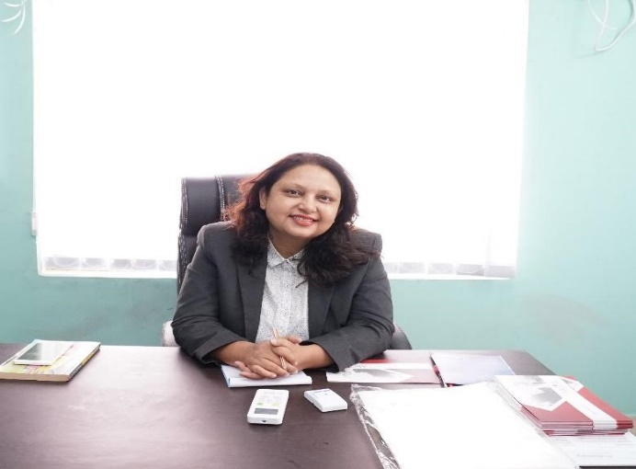 *Coach Anjana Tripathy*

Contact Details:

91- 9861177019

[coachanjana@gmail.com](mailto:coachanjana@gmail.com)

LinkedIn: www.linkedin.com/in/coach-anjana-tripathy-865985b1

Current Status: -

* Working as a 360 Degree Success Coach in close collaboration with Arfeen Khan Group of Companies
* Presently, working as A Senior Consultant (Training and Development ) with:

* Dr. Reddy’s Foundation for Health Education [ PAN India, especially Eastern India ]

Professional Experience :

* 21 years of diverse, cross industry experience in Organizational Development | Organizational Behavior | Training & Development | Recruitment | Talent Management | Talent Acquisition | Change Management | Human Resource Management

* Internationally Certified Life Coach
* Internationally Certified NLP Practitioner & NLP Technique – Based

Trainer. [ Certified by: ABNLP (American Board of Neuro Linguistic Programming) ]

* Certification in ‘HR Analytics’ from IIM, Rohtak
* Certified in Corporate Well-Being

Associations as a Senior Consultant:

* Dr. Reddy’s Foundation for Health Education ( DRFHE ) ( Travelled PAN India extensively ) – 2013 till present.
* Infosys , Bhubaneswar
* L & T Ltd. , Bhubaneswar
* IPCA Laboratories
* Blue Star Ltd. Kolkata
* Naandi Foundation
* JRT Foundation, USA [ *Global Project ]*
* Bhawani Group, Kolkata
* NSHM, Kolkata & Durgapur
* IHM, Kolkata
* IHM, Bhubaneswar
* KIIT, Bhubaneswar (Kalinga Institute of Industrial Technology, Bhubaneswar)
* BIITM School of Hotel Management, Bhubaneswar
* DRIEMS Engineering College, Tangi, Cuttack ( Dhaneswar Rath Institute of Engineering & Management Studies, Cuttack )
* AHA, Bhubaneswar (Air Hostess Academy, Bhubaneswar)
* BJB Autonomous College, Bhubaneswar
* Rama Devi Women’s Autonomous College, Bhubaneswar
* DPS, Kalinga, Bhubaneswar (Delhi Public school, Bhubaneswar)

(Teachers’ Orientation)

Full – Time Job Experience: ( Past )

* Lead HR Manager, Bhawani Group, Kolkata
* Training Head in Regional Academy of Hospitality & Aviation, Bhubaneswar. ( July, 2015 – June, 2016 )
* ITes Trainer in NIIT Planetworkz (P) Ltd., Bhubaneswar ( May, 2004 – March, 2005 )
* Assistant Manager (HR) in SEVEN HILLS (P) LTD, Bhubaneswar. ( MAY,2001 – DEC,2001 )

## Achievements:-

1. State Vice President – CorporateTalent Council, WICCI ( Women’s Indian Chamber of Commerce and Industry )
2. Awarded The Nari Shakti Award by Gyan Uday Foundation, Maharashtra
3. Featured as One of India’s Top Icons by BusinessTalkz Magazine
4. Featured as a Visionary Leader by Indyvarna
5. Earned 7 Linkedin Top Voice Badges, till date
6. Invited as an Esteemed Keynote Speaker by NSHM, Durgapur
7. A Proactive member of NIPM [ National Institute of Personnel Management ]
8. An active member of HR Sampark, an organization devoted to CSR activities.
9. Invited as a Keynote Speaker at the Induction Ceremony of Bhubaneswar School of Hotel Management & Tourism
10. Acted as Co-Judge in an Inter-School elocution competition organized by

“THE ROTARY CLUB”, Bhubaneswar in 2009.

1. Attendance and Participation in an interactive Seminar on: “Impactful Training Design and Delivery” organized by Asian College of Teachers.
2. Worked as an active member of the Durgapur Chapter of “The Eco-Club”. (An organization devoted to creating eco-awareness) for over one year.
3. Invited as one of the Expert Panelists in a Panel Discussion addressing UEM students, Kolkata

Professional Qualifications: -

* International Certification as a Life Empowerment Coach
* Post Graduate Diploma in Personnel Management from NIPM,

(National Institute of Personnel Management), Kolkata. [ Equivalent to MBA (HR)

* Executive Development Program in “HR Analytics” from IIM, Rohtak
* Internationally Certified NLP Practitioner

[American Board of Neuro

Linguistic Programming (ABNLP) ]

• Certified Corporate Wellness Expert

# EXTRA – MURAL ACTIVITY:-

A RESEARCH PROJECT undertaken as part of MBA (HR) in NALCO,

Bhubaneswar

# Topic:-

*“A CRITICAL STUDY ON THE IDENTIFICATION OF THE TRAINING NEEDS OF EXECUTIVES WORKING IN NALCO, WITH SPECIAL REFERENCE TO*

*CORPORATE EXECUTIVES.”*

## Personal Profile:-

NAME : Anjana Tripathy

DOB : 14th February, 1970

Languages Known : English, Hindi, Bengali and Odia

Hobbies: Coaching, Volunteering, Networking, Writing

Address: Flat - 1A, Gitanjali Apartment,

Husseinpur,

( Near Anandapur Police Station)

Kolkata - 700107

Declaration:

All the above-mentioned details are true to the best of my knowledge and belief.

* Anjana Tripathy
* Kolkata