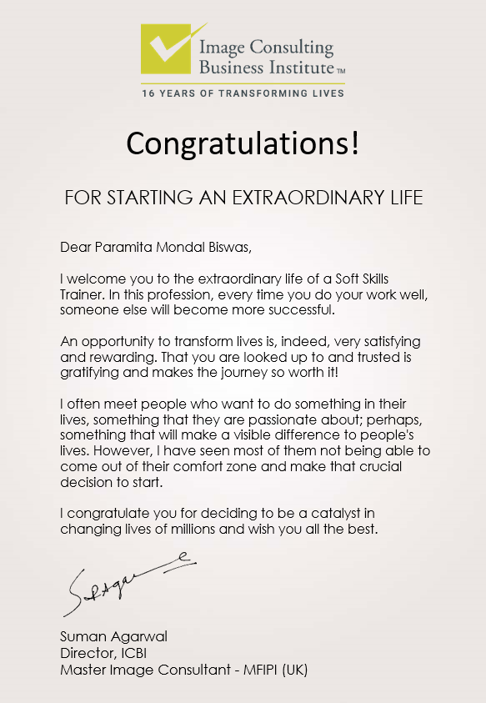

Post:

Today made my day! It's a proud moment when you receive such a warm welcome from @SumanAgarwal, senior most image consultant in the Indian sub-continent and co-founder of @ImageConsultingBusinessInstitute

#icbi #imageconsultingbusinessinstitute #imageconsulting #imageconsultant #softskills #softskillstraining #success #entrepreneur #firstimpressions

----------------------------------------------------------------

(Continued)

Social Media Post 3

Visual:

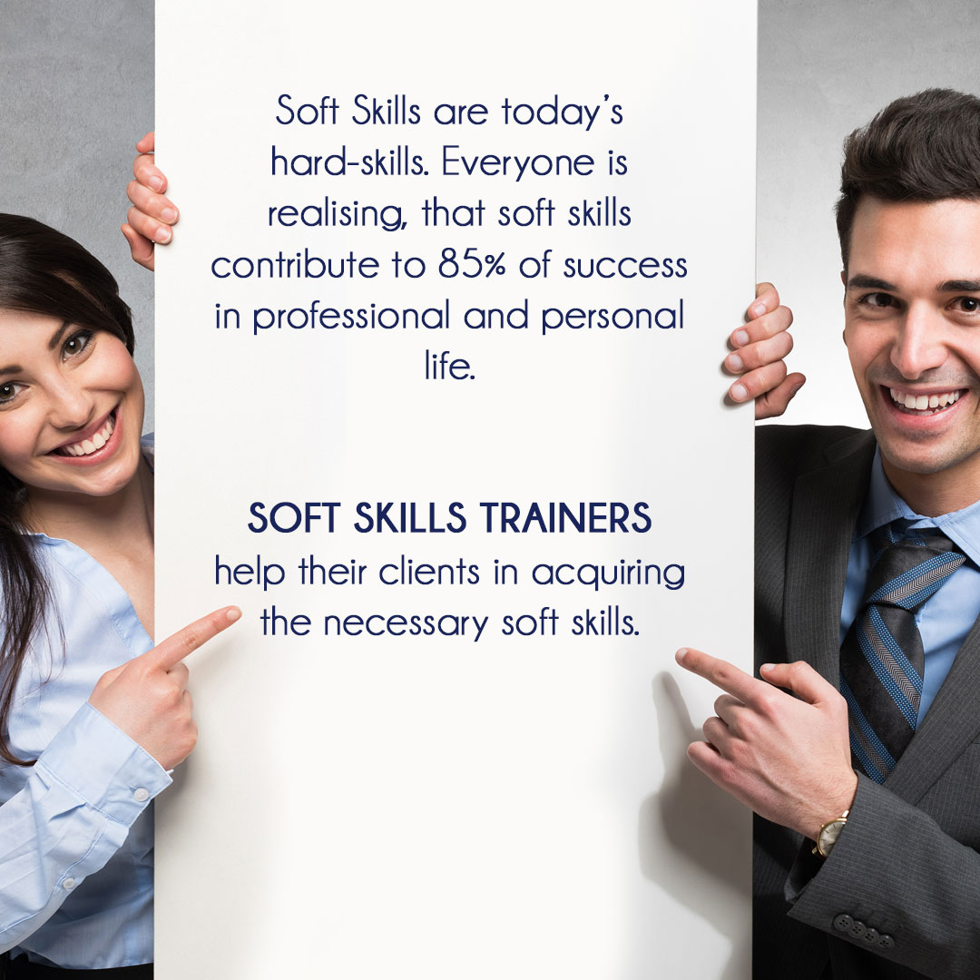

Post:

It’s not about just getting a good job, it’s also about retaining it, and growing in it. Soft Skills Training is so important for everyone, I feel. Now eagerly waiting for my certification so that I can pursue my calling and start training others on how to appear, behave and communicate.
#icbi #imageconsultingbusinessinstitute #imageconsulting #imageconsultant #softskills #softskillstraining #success #firstimpressions #newbeginnings

